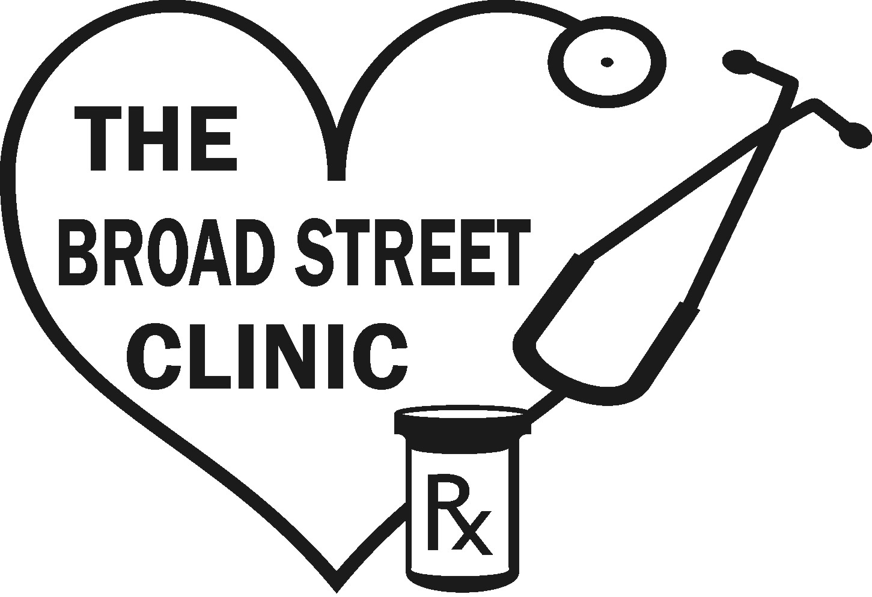
July 1, 2013 – June 30, 2014
Annual Report

Chairman’s message

This year the Broad Street Clinic celebrated its 20th anniversary serving low-income adults in Cateret County with diabetes, hypertension, cardiovascular disease, pulmonary disease and thyroid disease. With the lack of Medicaid expansion in North Carolina, we continue to see more than 900 patients with many new patients coming each month.
As a member of the National and North Carolina Association of Free Clinics, all medical providers and nurses are volunteers. Overall, we have 80 volunteers that also staff the pharmacy, front desk and help with fundraising. Our Medical Care Committee has initiated quarterly quaility assurance initiatives to monitor and help improve our care. We are proud that this year we had the fewest patients with an A1C over 9 in the state and were awarded $1500!
Among our other accomplishments, we began an Eye Clinic and a Foot Care Clinic for our diabetic patients. We have also hired a
The mission of the Broad Street Clinic is to provide health care services for certain chronic diseases to low income adults of Carteret County and surrounding areas.

The vision of the Broad Street Clinic will meet the increasing demand for services and improve overall health of our patients.

Volunteer Coordinator to streamline volunteer schedules and maintain yearly credentialing.
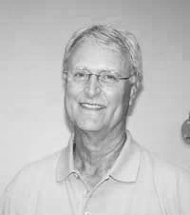
Fundraising continues to be a very important task in order to be able to provide all the services that our patients need. With the changes in medical care, we continue to lose support for providing free medications from pharmaceutical companies. Fortunately, we continue to receive generous support from the community and Carteret General Hospital. This year we were also accepted as a recipient of funding from the Coastal Carolina United Way. We hope you will continue to support the Broad Street Clinic that provides medical care for so many in our county and surrounding areas.
Please come visit
us at the clinic!
Frederick C. Heaton, MD
Chairman of the Board

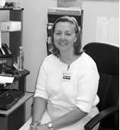
Executive Director’s Message
The year was another exciting and busy one. We are so fortunate to have over 20 volunteer health care providers, 20 volunteer nurses, and 4 pharmacists to provide services to the Clinic. Another 60 people complete the rest of our volunteer staff. Each week volunteers work 165 hours to keep the Clinic operating.
Clyde Edgerton, NC author and entertainer, helped us celebrate our 20th Anniversary with a fundraiser and celebration. Clyde had been a longtime supporter of the Clinic and we look forward to his help every other year.
During April, I was pleased to be able to present Dr. Mark Heffington with the Don Lucy Award. This is the highest award given by the NC Association of Free Clinics to a volunteer. Dr. Heffinton has been a volunteer at the Clinic since 2008. He was nominated for this prestigious award by Merci Clinic of New Bern, Hope Clinic of Bayboro and our very own Broad Street Clinic for his volunteer efforts at all three clinics. He is the founder of the free clinic in Cashiers, NC.
A health fair was held in September with the NC Farm Bureau. This fun, free event was for insured and uninsured residents of Carteret County. Participants received free flu vaccines, A1C glucose tests, cholesterol screenings and breathing tests. Participants also received information about exercise and healthy lifestyle changes. Farm Bureau donated $5,000 to help us with our mission.
The NC Men’s Baptist Association Dental Bus was on site four days during the year. Over 120 patients were able to receive preventative care, extractions and fillings. Local dentists, hygienists and assistants worked the dental bus to deliver these services.
Patient surveys indicated 96% of patients felt better during the year because of treatment at the Clinic. Patients also reported a 96% decrease in work absenteeism. Other accomplishments include the marketing committee working with BellaGurl to design a new website and update our Facebook page.

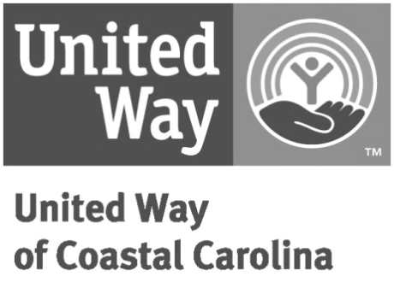
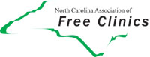
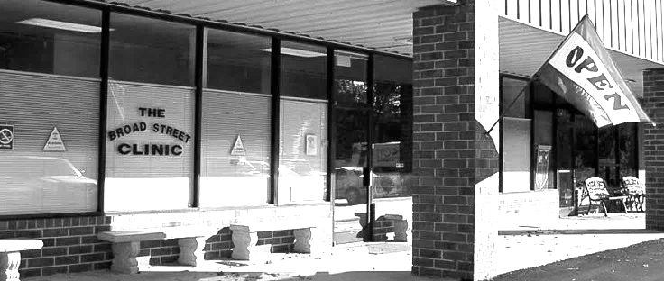
For every $1 in donations we provide $29 in services!
Hours
Volunteer Medical Staff Reported

Pharmacy Tech 225

Diabetic Educator 48

Counselor 96

Physician Assistant 52

Dentist 64

Hygienist 32

Dental Assistants 64

Pharmacists 672

Nurse Practitioners 459

RN’s 1040

Physicians 2288
Broad Street Clinic Board of Directors:
Broad Street Clinic
Board of Directors

- Dr. Chris Heaton, Chairman
- John Lee, Vice Chairman
- Linda Murphy, Treasurer
- Mary Frances Wright, Secretary
- Dr. Mary Katherine Lawrence, Medical Director
- Marty Beam
- Jane Heaton
- Mike Morelli
- Laura Niedosik
- Joe Smith
- Harvey Walker
- Sarah West
- Lon Pollard
- Donna Getty
- Andrea McLean

Broad Street Clinic Board of
Directors

Dr. Chris, Heaton, Chairman
John Lee, Vice Chairman
Linda Murphy, Treasurer
Mary Frances Wright, Secretary
Dr. Mary Katherine Lawrence, Medical Director
Marty Beam
Alice Cundiff
Jane Heaton
Peg Midyette
Mike Morelli
Laura Niedosik
Joe Smith
Ken Turner
Harvey Walker
Sarah West

Please e-mail us at freeclinic@bizec.rr.com to help us create an electronic mailing list. This will enable us to send you information about upcoming events and services.

Five years ago, our patient MC moved to Carteret County to care for her elderly parents. She left a waitress position that provided her with health insurance that allowed her to manage her diabetes. While caring for her parents was her priority, she had no plans for her own health care. Through a family member, she heard about the Broad Street Clinic. When she became a patient here her A1c was 11.3. Following the American Diabetes Association guidelines, a target goal A1c is 7. The Broad Street Clinic has been able to provide regular visits to a physician, diabetic education, and medications to work toward that goal. Her A1c is now 6.8. She is able to test her glucose on a daily basis with testing strips provided by the Clinic and make adjustments to her insulin based on those readings. When asked about BSC, she feels that the Clinic has allowed her the opportunity to provide care to her parents, work a part time job and still feel good without having health insurance. She has access to what she needs for her health. BSC has provided her with regular mammograms, gynecological appointments, an eye exam and dental services.
Patient story of success!
534 N. 35th Street, Suite K
Morehead City, NC 28557
252.726.4562
freeclinic@bizec.rr.com
www.broadstreetclinic.org

.

